Data Structures Applications Lab (21EECF201) [0-0-2]
Term-work Report

Term-work | 01
Student Name | Praveen Magadum
SRN | 02FE21BEC064 |  |  |  | Roll Number |  | 60 |  | Division | A
Code of ethics:
I hereby declare that I am bound by ethics and have not copied any text/program/figure without acknowledging the content creators. I abide to the rule that upon plagiarized content all my marks will be made to zero.
Digital signature of the student
Apply Programming Skills  (5 marks) |  | Identify Constraints and Implement  (10 marks) |  | Integrate Modules  (3 Marks) |  | Debugging and Tool usage  (2 marks) |  | Remarks |  |  | Total  (20 Marks)
Problem Statement
Explain the operation of each algorithm type, take into account two examples of programmes for each algorithm type, and express the time complexity of each programme.
- Iterative, 2. Recursive, 3. Back tracking, 4. Divide and conquer, 5. Dynamic programming,
- Greedy, 7. Branch and Bound, 8. Brute force, 9. Randomized
Type of algorithm | Example No |  | Which data structures are used? |  |  |  |  | What is the time complexity? O(n)
Iterative | 1 |  | 1D Array |  |  |  |  | O(n)
Iterative | 2 |  | 1D Array |  |  |  |  | O(n)
Recursive | 1 |  | 1D Array |  |  |  |  | O(n)
Recursive | 2 |  | 1D Array |  |  |  |  | 0(n)
Back tracking | 1 |  | 1D Array |  |  |  |  | O(n*n!)
Back tracking | 2 |  | 1D Array |  |  |  |  | O(N^N)
Divide and conquer | 1 |  | 1D Array |  |  |  |  | O(N^2)
Divide and conquer | 2 |  | 1D Array |  |  |  |  | O(N log(N))
Dynamic programming | 1 |  | 1D Array |  |  |  |  | O(n)
Dynamic programming | 2 |  | 1D Array |  |  |  |  | O(n*amount)
Greedy | 1 |  | 1D Array |  |  |  |  | O(numCoins^2)
Greedy | 2 |  | 1D Array |  |  |  |  | O(numactivities)
Branch and bound | 1 |  | 1D Array |  |  |  |  | O(2^n)
Branch and bound | 2 |  | 1D Array |  |  |  |  | O(N!)
Brute force | 1 |  | 1D Array |  |  |  |  | O((n - m + 1))
Brute force | 2 |  | 1D Array |  |  |  |  | O(n)
Randomized | 1 |  | 1D Array |  |  |  |  | O(1)
Randomized | 2 |  | 1D Array |  |  |  |  | O(count)

1. Iterative Algorithm

Example 1 :
// File processing line by line

#include<stdio.h>
int main() {
FILE *file = fopen("log.txt", "r");
if (file == NULL) {
printf("Error opening file.\n");
return 1;}
char line[256];
while (fgets(line, sizeof(line), file) != NULL)
{
// Process each line of the file
printf("Line: %s", line);
// Perform analysis or filtering
// Uncomment the line below to add a delay between processing each line
// usleep(500000); // Pause for 500 milliseconds (0.5 seconds)
}
fclose(file);
return 0;
}

OUTPUT :

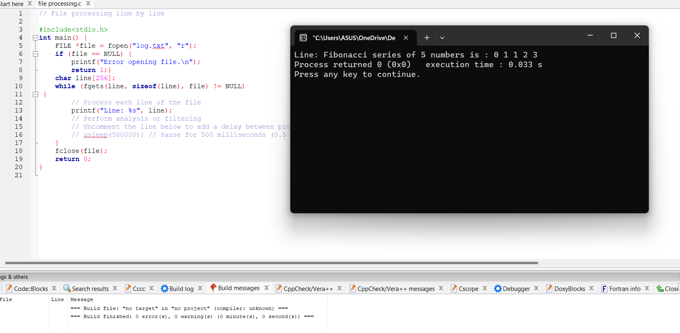

EXAMPLE 2:
// Timer Program to count the time in Reverse way
#include <stdio.h>
#include <unistd.h>

int main() {
int timer = 10; // Start from 10 seconds

while (timer >= 0)
{
printf("Timer: %d\n", timer);
sleep(1); // Pause for 1 second
timer--;
}

printf("Time's up!\n");

return 0;
}

OUTPUT :

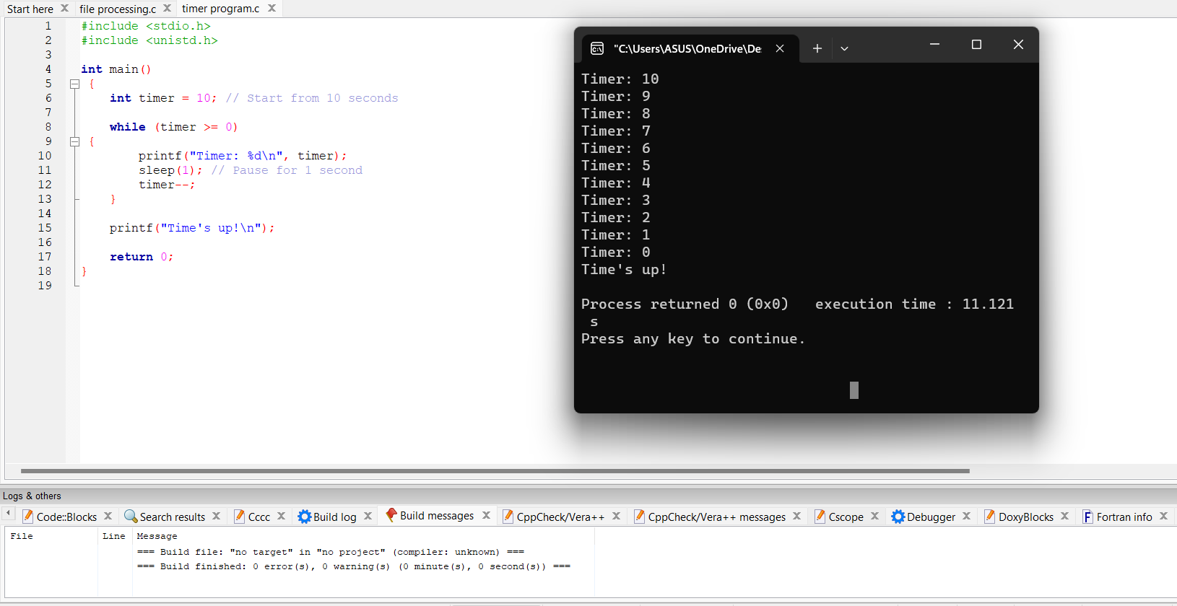

2. Recursive Algorithm

EXAMPLE 1 :
//Exponential Calculation

#include <stdio.h>
int power(int base, int exponent)
{
if (exponent == 0) return 1;
else
return base * power(base, exponent - 1);
}
int main()
{
int base, exponent;
printf("Enter the base number: "); scanf("%d", &base);
printf("Enter the exponent: "); scanf("%d", &exponent);
int result = power(base, exponent);
printf("%d raised to the power of %d is %d\n", base, exponent, result);

return 0;
}

OUTPUT:

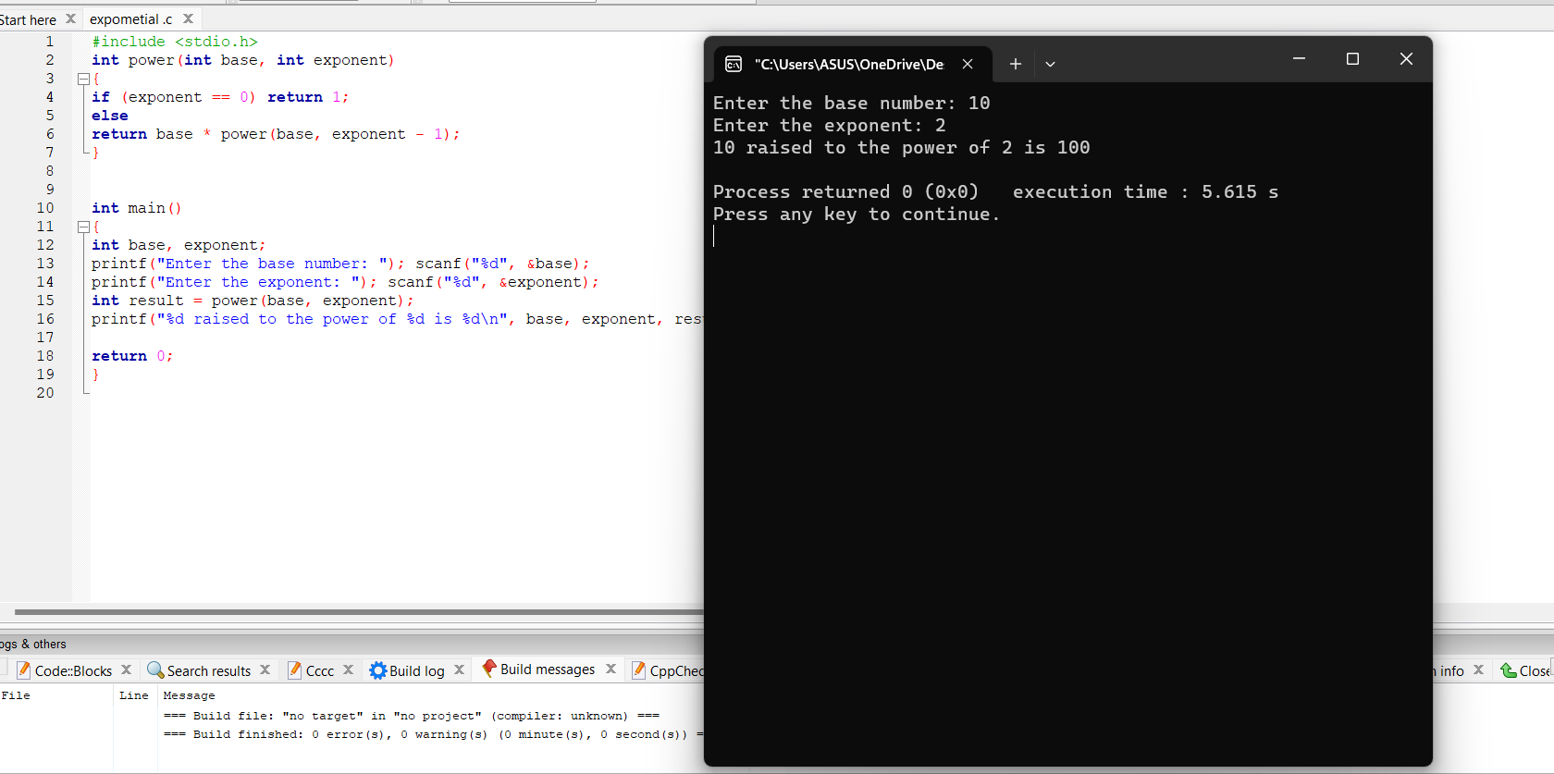

EXAMPLE 2:
// Program to find the factorial of a number 5

#include <stdio.h>
int f(int n)
{
// Stop condition
if (n == 0 || n == 1)
return 1;
// Recursive condition
else
return n * f(n - 1);
}

// Driver code
int main()
{
int n = 5;
printf("factorial of %d is: %d", n, f(n));
return 0;
}

OUTPUT :

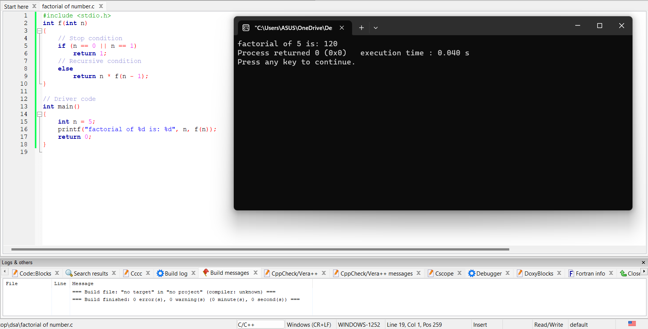

3. Backtracking Algorithm

EXAMPLE 1 :
// C program to print all permutations with duplicates

#include <stdio.h>
#include <string.h>
void swap(char* x, char* y)
{
char temp;
temp = *x;
*x = *y;
*y = temp;
}

void permute(char* a, int l, int r)
{
int i;
if (l == r)
printf("%s\n", a);
else {
for (i = l; i <= r; i++) {
swap((a + l), (a + i));
permute(a, l + 1, r);
swap((a + l), (a + i)); // backtrack
}
}
}

/* Driver code */
int main()
{
char str[] = "ABC";
int n = strlen(str);
permute(str, 0, n - 1);
return 0;
}

OUTPUT :

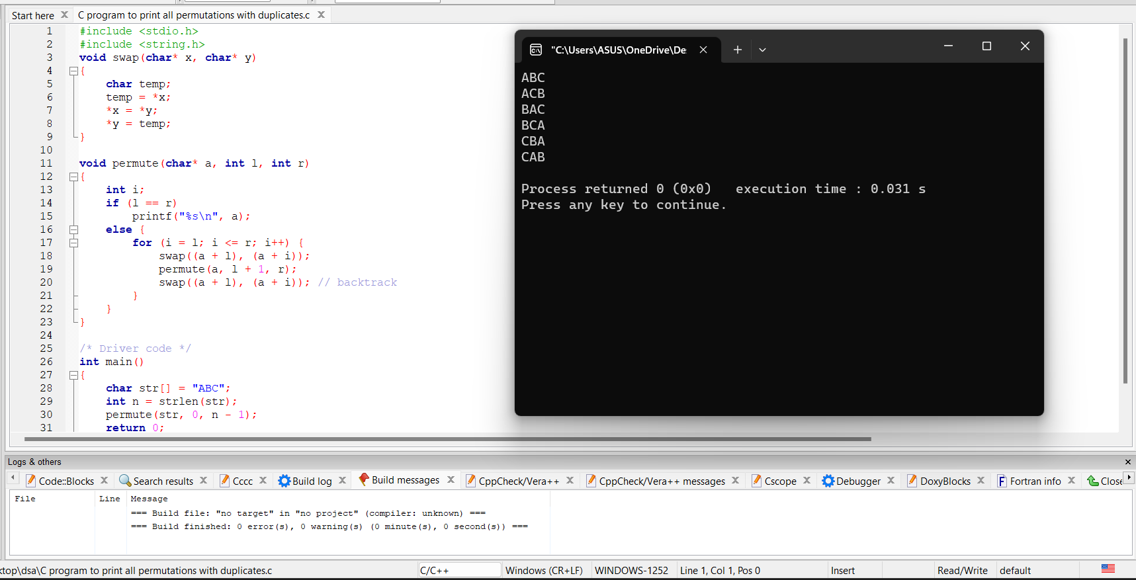

EXAMPLE 2 :
//N queens Algorithm

#include <stdio.h>
#define N 8
int isSafe(int board[N][N], int row, int col) {
int i, j;
// Check the left side of the current row
for (i = 0; i < col; i++)
if (board[row][i])
return 0;
// Check the upper diagonal on the left side
for (i = row, j = col; i >= 0 && j >= 0; i--, j--)
if (board[i][j])
return 0;
// Check the lower diagonal on the left side
for (i = row, j = col; j >= 0 && i < N; i++, j--)
if (board[i][j])
return 0;
return 1;
}
int solveNQueens(int board[N][N], int col) {
// Base case: If all queens are placed, return true
if (col >= N)
return 1;
// Consider each row in the current column
for (int i = 0; i < N; i++) {
// Check if the queen can be placed in the current position
if (isSafe(board, i, col)) {
// Place the queen
board[i][col] = 1;
// Recursively solve the problem for the next column
if (solveNQueens(board, col + 1))
return 1;
// If placing the queen in the current position doesn't lead to a solution,
// backtrack by removing the queen from the current position
board[i][col] = 0;
}
}
// If no queen can be placed in the current column, return false
return 0;
}

void printBoard(int board[N][N]) {
for (int i = 0; i < N; i++) {
for (int j = 0; j < N; j++)
printf("%d ", board[i][j]);
printf("\n");
}
}

int main() {
int board[N][N] = {0};

if (solveNQueens(board, 0))
printBoard(board);
else
printf("No solution found.");

return 0;
}

OUTPUT :

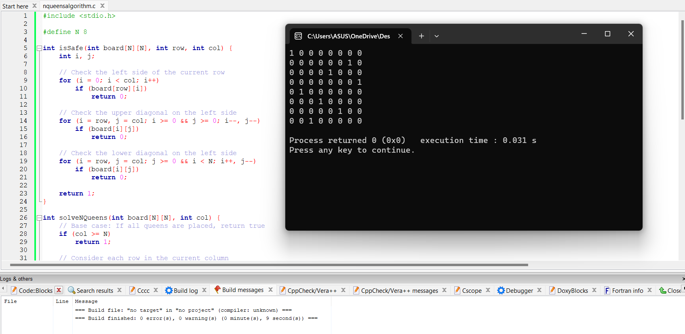

4. Divide and conquer Algorithm

EXAMPLE 1 :
// C code to implement quicksort

#include <stdio.h>
// Function to swap two elements
void swap(int* a, int* b)
{
int t = *a;
*a = *b;
*b = t;
}
// Partition the array using the last element as the pivot
int partition(int arr[], int low, int high)
{
// Choosing the pivot
int pivot = arr[high];
// Index of smaller element and indicates
// the right position of pivot found so far
int i = (low - 1);
for (int j = low; j <= high - 1; j++) {
// If current element is smaller than the pivot
if (arr[j] < pivot) {
// Increment index of smaller element
i++;
swap(&arr[i], &arr[j]);
}
}
swap(&arr[i + 1], &arr[high]);
return (i + 1);
}
// The main function that implements QuickSort
// arr[] --> Array to be sorted,
// low --> Starting index,
// high --> Ending index
void quickSort(int arr[], int low, int high)
{
if (low < high) {

// pi is partitioning index, arr[p]
// is now at right place
int pi = partition(arr, low, high);

// Separately sort elements before
// partition and after partition
quickSort(arr, low, pi - 1);
quickSort(arr, pi + 1, high);
}
}
// Driver code
int main()
{
int arr[] = { 10, 7, 8, 9, 1, 5 };
int N = sizeof(arr) / sizeof(arr[0]);
// Function call
quickSort(arr, 0, N - 1);
printf("Sorted array: \n");
for (int i = 0; i < N; i++)
printf("%d ", arr[i]);
return 0;
}

OUTPUT :

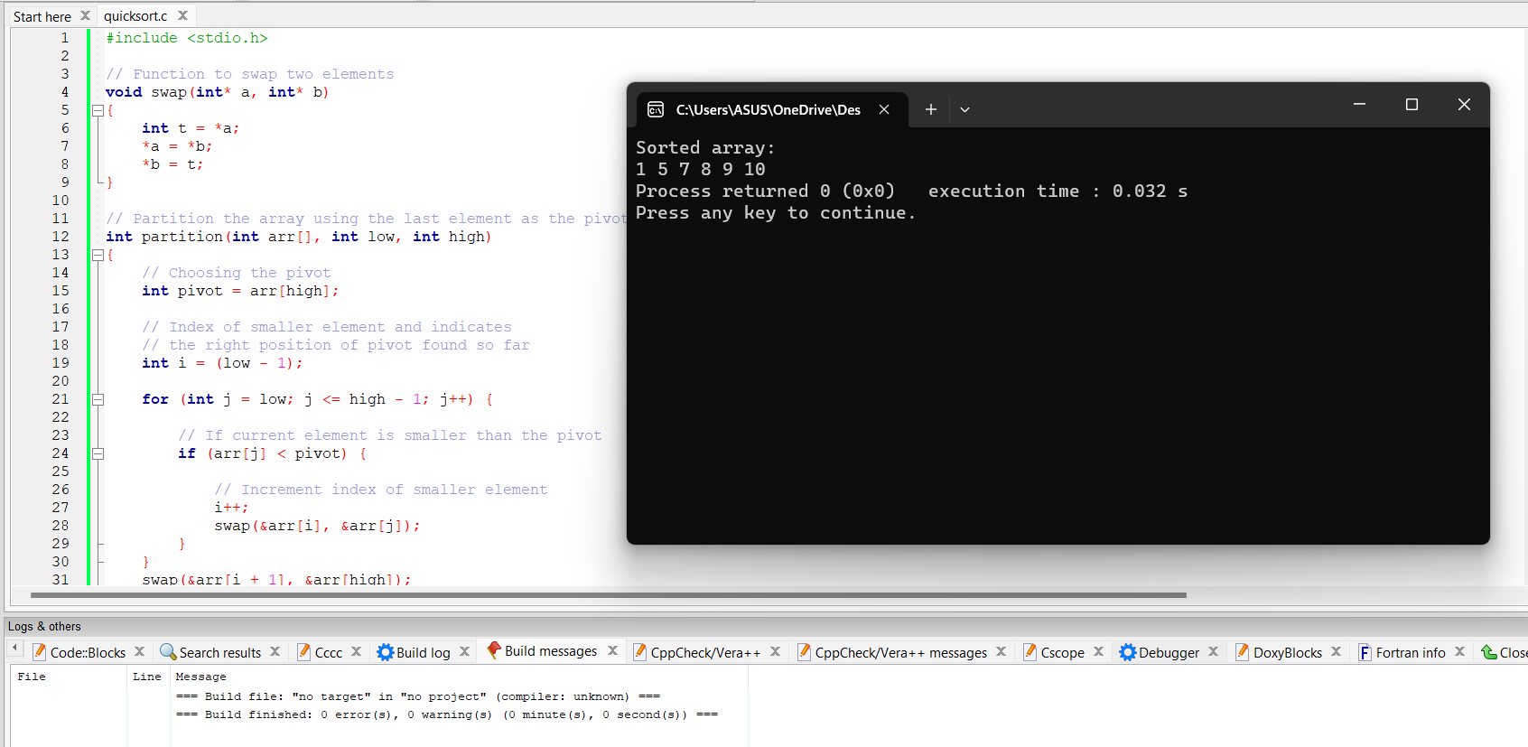
EXAMPLE 2 :
// C program for Merge Sort

#include <stdio.h>
#include <stdlib.h>

// Merges two subarrays of arr[].
// First subarray is arr[l..m]
// Second subarray is arr[m+1..r]
void merge(int arr[], int l, int m, int r)
{
int i, j, k;
int n1 = m - l + 1;
int n2 = r - m;

// Create temp arrays
int L[n1], R[n2];

// Copy data to temp arrays L[] and R[]
for (i = 0; i < n1; i++)
L[i] = arr[l + i];
for (j = 0; j < n2; j++)
R[j] = arr[m + 1 + j];

// Merge the temp arrays back into arr[l..r
i = 0;
j = 0;
k = l;
while (i < n1 && j < n2) {
if (L[i] <= R[j]) {
arr[k] = L[i];
i++;
}
else {
arr[k] = R[j];
j++;
}
k++;
}

// Copy the remaining elements of L[],
// if there are any
while (i < n1) {
arr[k] = L[i];
i++;
k++;
}

// Copy the remaining elements of R[],
// if there are any
while (j < n2)
{
arr[k] = R[j];
j++;
k++;
}
}

// l is for left index and r is right index of the
// sub-array of arr to be sorted
void mergeSort(int arr[], int l, int r)
{
if (l < r)
{
int m = l + (r - l) / 2;

// Sort first and second halves
mergeSort(arr, l, m);
mergeSort(arr, m + 1, r);

merge(arr, l, m, r);
}
}

// Function to print an array
void printArray(int A[], int size)
{
int i;
for (i = 0; i < size; i++)
printf("%d ", A[i]);
printf("\n");
}
// Driver code
int main()
{
int arr[] = { 12, 11, 13, 5, 6, 7 };
int arr_size = sizeof(arr) / sizeof(arr[0]);
printf("Given array is \n");
printArray(arr, arr_size);
mergeSort(arr, 0, arr_size - 1);
printf("\nSorted array is \n");
printArray(arr, arr_size);
return 0;
}

OUTPUT :

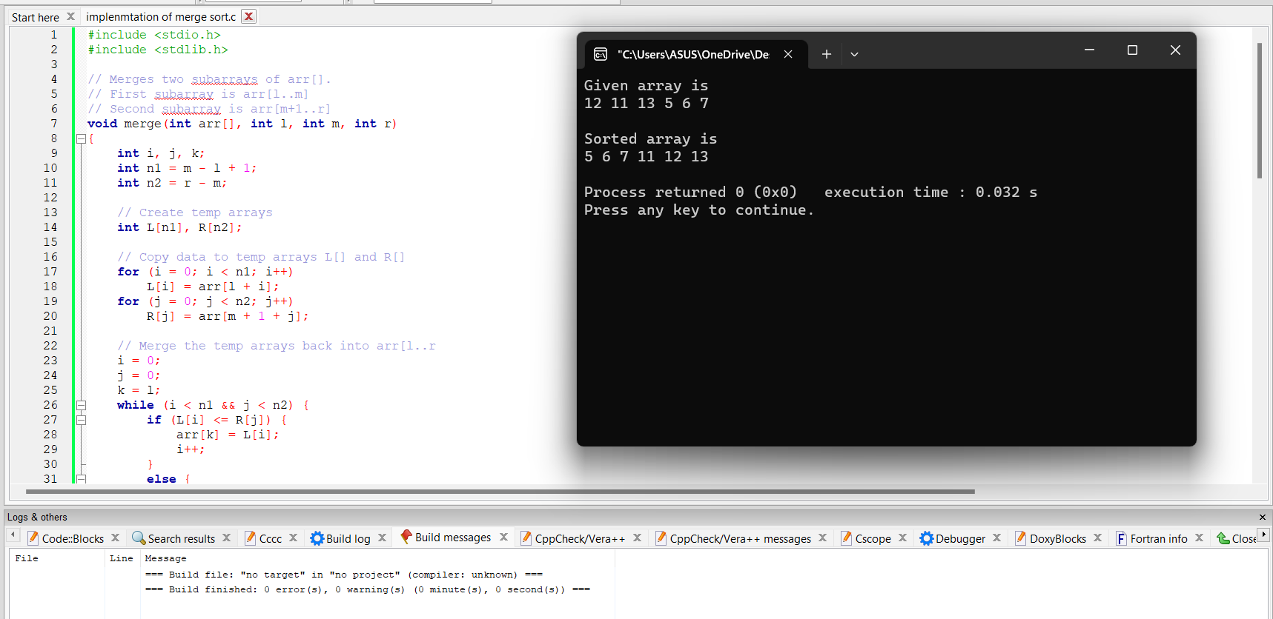

5. Dynamic Programming

EXAMPLE 1 :
// Finding the Fibonacci number in a sequence
#include <stdio.h>
int fibonacci(int n) {
int fib[n + 1];
int i;
fib[0] = 0; // Base case: F(0) = 0
fib[1] = 1; // Base case: F(1) = 1

for (i = 2; i <= n; i++) {
// Calculate the current Fibonacci number by adding the previous two numbers
fib[i] = fib[i - 1] + fib[i - 2];
}
return fib[n];
}
int main() {
int n;
printf("Enter the value of n: ");
scanf("%d", &n);
printf("The %dth Fibonacci number is: %d\n", n, fibonacci(n));
return 0;
}

OUTPUT :

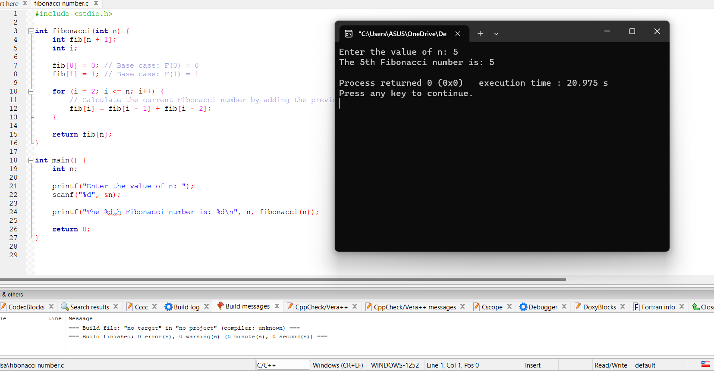

EXAMPLE 2:
// solving the problem of finding the minimum number of coins needed to make change for a given amount

#include <stdio.h>
#include <limits.h>
int minCoins(int coins[], int n, int amount) {
int dp[amount + 1]; // Table to store the minimum number of coins for each amount
int i, j;

// Initialize the table with infinity
for (i = 1; i <= amount; i++) {
dp[i] = INT_MAX;
}

// Base case: The minimum number of coins needed to make change for 0 is 0
dp[0] = 0;

// Compute the minimum number of coins for each amount
for (i = 1; i <= amount; i++) {
// Try each coin denomination
for (j = 0; j < n; j++) {
if (coins[j] <= i && dp[i - coins[j]] != INT_MAX) {
// If using the current coin leads to a smaller number of coins needed, update the table
dp[i] = dp[i] < 1 + dp[i - coins[j]] ? dp[i] : 1 + dp[i - coins[j]];
}
}
}

return dp[amount];
}

int main() {
int coins[] = {1, 5, 10, 25};
int n = sizeof(coins) / sizeof(coins[0]);
int amount;

printf("Enter the amount: ");
scanf("%d", &amount);

int result = minCoins(coins, n, amount);

if (result != INT_MAX) {
printf("Minimum number of coins needed: %d\n", result);
} else {
printf("No solution found.\n");
}

return 0;
}

OUTPUT :

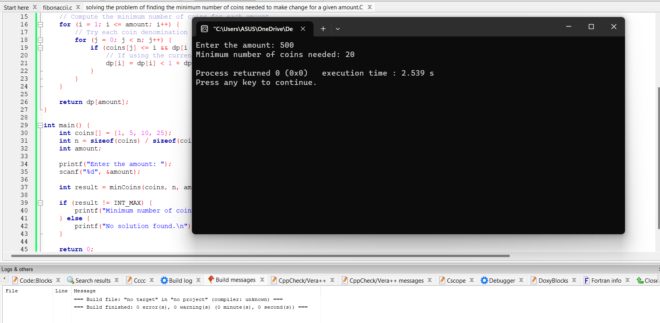
6. Greedy Algorithm

EXAMPLE 1 :
// Function to find the minimum number of coins needed to make change

#include <stdio.h>
// Function to find the minimum number of coins needed to make change
int coinChangeGreedy(int coins[], int numCoins, int targetAmount)
{
// Sort the coins in descending order
for (int i = 0; i < numCoins - 1; i++) {
for (int j = 0; j < numCoins - i - 1; j++) {
if (coins[j] < coins[j + 1]) {
int temp = coins[j];
coins[j] = coins[j + 1];
coins[j + 1] = temp;
}
}
}

int numCoinsUsed = 0;

// Iterate through the coins and select the largest denomination that is less than or equal to the remaining amount
for (int i = 0; i < numCoins; i++) {
while (targetAmount >= coins[i]) {
targetAmount -= coins[i];
numCoinsUsed++;

}
}

return numCoinsUsed;
}

int main() {
int coins[] = {25, 10, 5, 1}; // Available coin denominations
int numCoins = sizeof(coins) / sizeof(coins[0]);

int targetAmount = 63; // Target amount for which change is to be made

int minCoins = coinChangeGreedy(coins, numCoins, targetAmount);

printf("Minimum number of coins needed: %d\n", minCoins);

return 0;
}

OUTPUT :

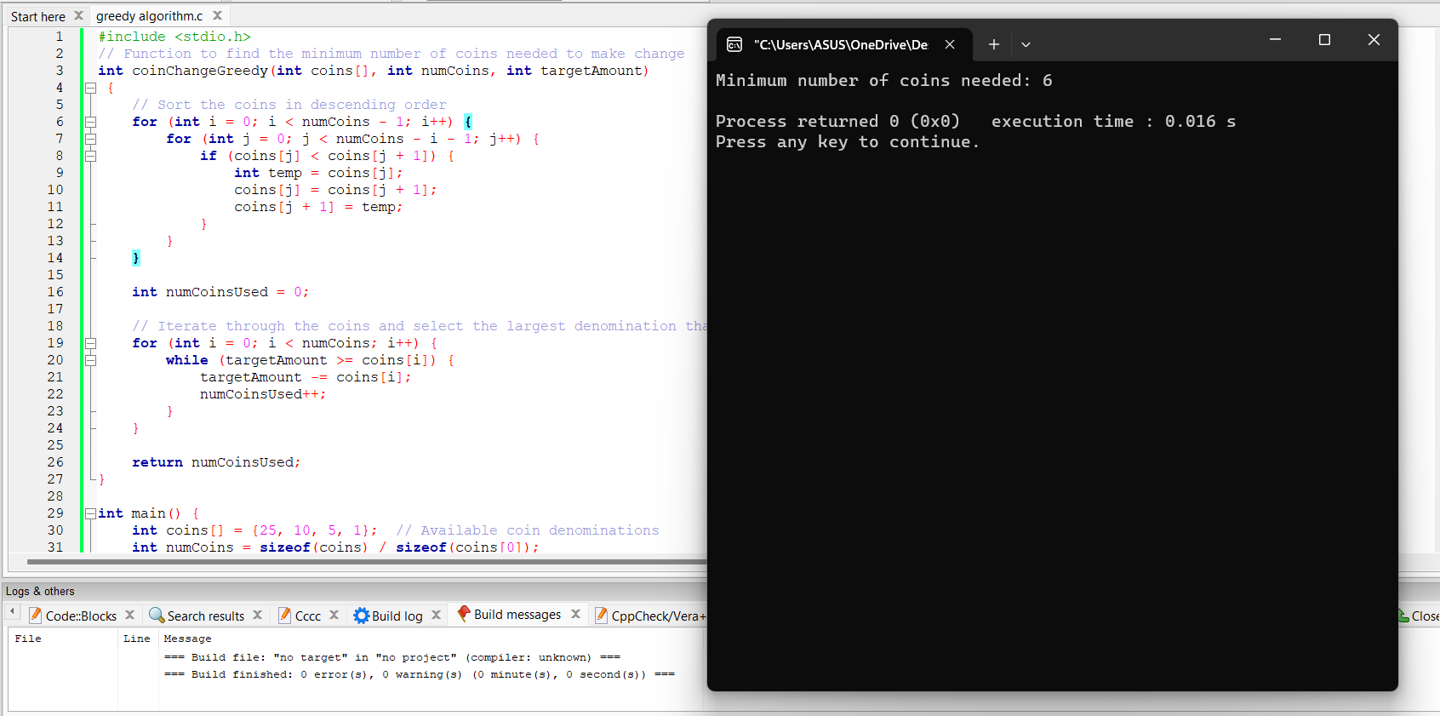

EXAMPLE 2 :
// Greedy algorithm to solve the Activity Selection Problem

#include <stdio.h>
// Structure to represent an activity
typedef struct {
int start;
int finish;
} Activity;
int compareActivities(const void* a, const void* b) {
Activity* activityA = (Activity*)a;
Activity* activityB = (Activity*)b;

return activityA->finish - activityB->finish;
}

// Greedy algorithm to solve the Activity Selection Problem
void activitySelectionGreedy(Activity activities[], int numActivities) {
qsort(activities, numActivities, sizeof(Activity), compareActivities); // Sort activities based on their finish time

printf("Selected Activities:\n");

int previousFinishTime = -1;

for (int i = 0; i < numActivities; i++) {
if (activities[i].start >= previousFinishTime) {
printf("Activity %d: Start Time = %d, Finish Time = %d\n", i+1, activities[i].start, activities[i].finish);
previousFinishTime = activities[i].finish;
}
}
}

int main() {
Activity activities[] = {
{1, 4},
{3, 5},
{0, 6},
{5, 7},
{3, 9},
{5, 9},
{6, 10},
{8, 11},
{8, 12},
{2, 14},
{12, 16}
};

int numActivities = sizeof(activities) / sizeof(activities[0]);

activitySelectionGreedy(activities, numActivities);

return 0;
}

OUTPUT :
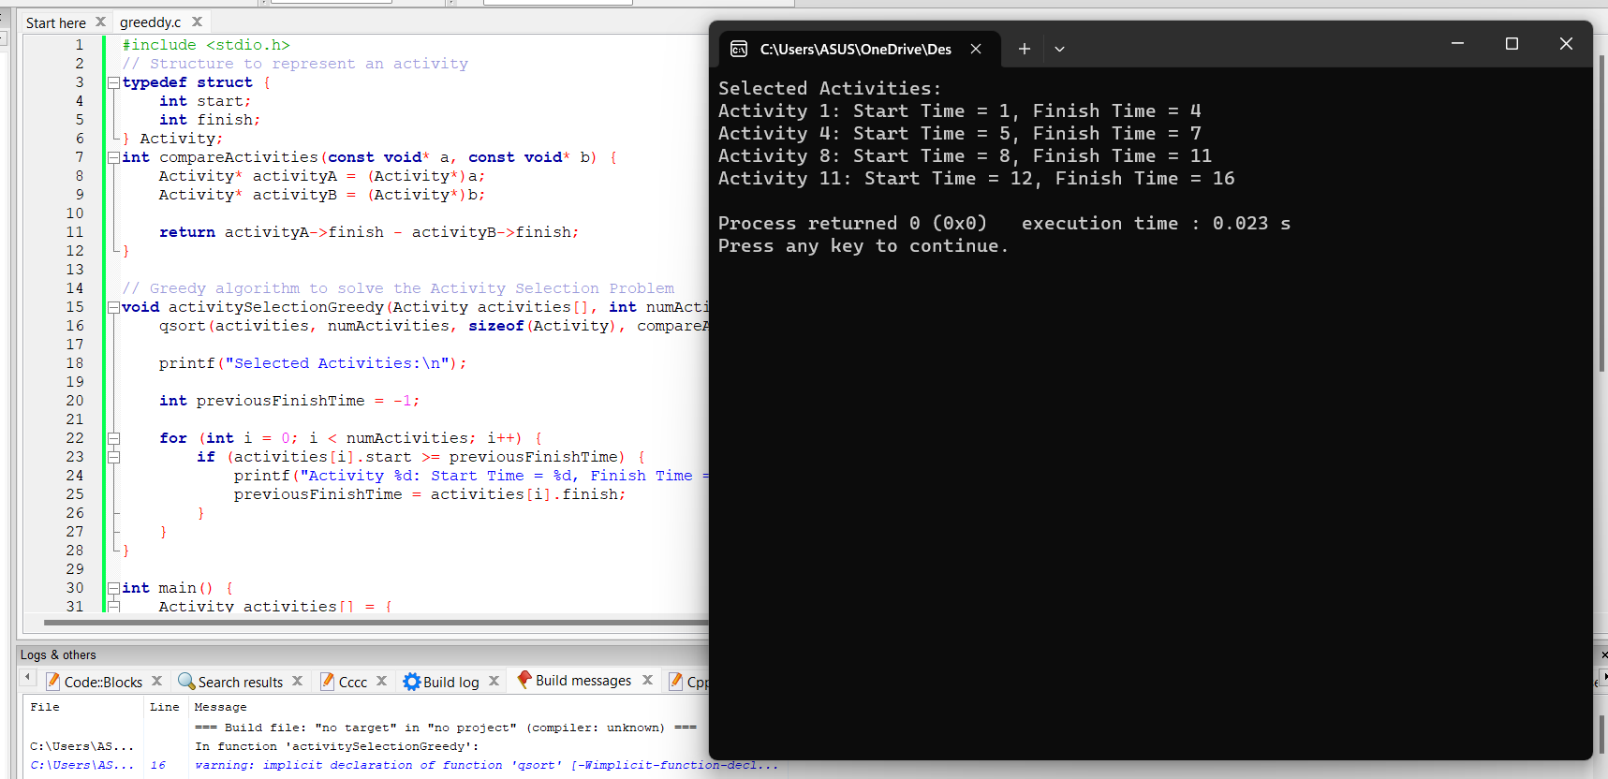

7. Brute Force Algorithm

EXAMPLE 1 :
// Brute force algorithm for finding pattern index

#include <stdio.h>
#include <string.h>
int bruteForceStringMatch(const char* text, const char* pattern)
{
int n = strlen(text);
int m = strlen(pattern);
for (int i = 0; i <= n - m; i++) {
int j;
for (j = 0; j < m; j++) {
if (text[i + j] != pattern[j])
break;
}
if (j == m)
return i; // Pattern found at index i
}
return -1; // Pattern not found
}
int main() {
const char* text = "Hello, World!";
const char* pattern = "World";
int index = bruteForceStringMatch(text, pattern);
if (index != -1)
printf("Pattern found at index %d\n", index);
else
printf("Pattern not found\n");
return 0;
}

OUTPUT :

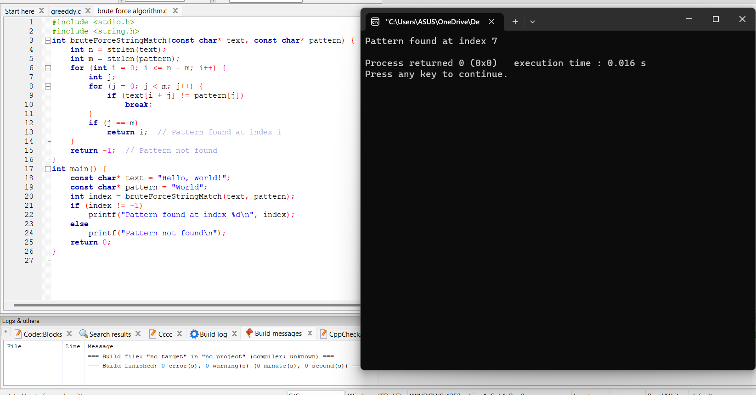

EXAMPLE 2 :
// PROGRAM TO CHECK THE GIVEN NUMBER IS PRIME NUMBER OR NOT A PRIME NUMBER

#include <stdio.h>
int isPrime(int num)
{
if (num <= 1)
return 0; // Not a prime
for (int i = 2; i <= num / 2; i++) {
if (num % i == 0)
return 0; // Not a prime
}
return 1; // Prime number
}
int main()
{
int num = 17;
if (isPrime(num))
printf("%d is a prime number\n", num);
else
printf("%d is not a prime number\n", num);
return 0;
}

OUTPUT :

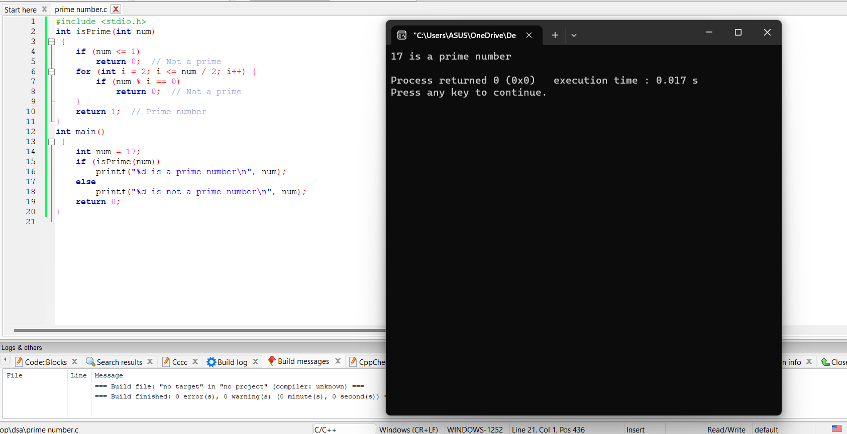

8. Branch and Bound

EXAMPLE 1 : Knapsack Problem
#include <stdio.h>
#include <stdbool.h>
int max(int a, int b) {
return (a > b) ? a : b;
}
int knapsack(int values[], int weights[], int capacity, int n) {
if (n == 0 || capacity == 0)
return 0;

if (weights[n - 1] > capacity)
return knapsack(values, weights, capacity, n - 1);

int included = values[n - 1] + knapsack(values, weights, capacity - weights[n - 1], n - 1);
int excluded = knapsack(values, weights, capacity, n - 1);

return max(included, excluded);
}
int main() {
int values[] = {60, 100, 120};
int weights[] = {10, 20, 30};
int capacity = 50;
int n = sizeof(values) / sizeof(values[0]);
int maxProfit = knapsack(values, weights, capacity, n);
printf("Maximum profit: %d\n", maxProfit);

return 0;
}

OUTPUT:

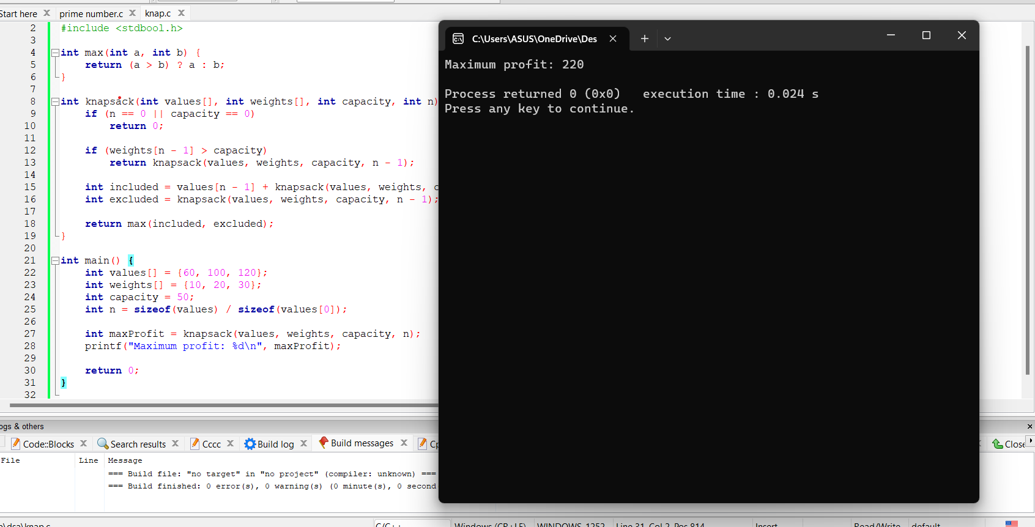

EXAMPLE 2: SALESMAN PROBLEM
#include <stdio.h>
#include <stdbool.h>
#include <limits.h>

#define N 4

int graph[N][N] = {
{0, 10, 15, 20},
{10, 0, 35, 25},
{15, 35, 0, 30},
{20, 25, 30, 0}
};

int minCost = INT_MAX;
bool visited[N] = {false};

void tsp(int current, int cost, int count) {
if (count == N && graph[current][0] > 0) {
minCost = (cost + graph[current][0] < minCost) ? cost + graph[current][0] : minCost;
return;
}

for (int i = 0; i < N; i++) {
if (!visited[i] && graph[current][i] > 0) {
visited[i] = true;
tsp(i, cost + graph[current][i], count + 1);
visited[i] = false;
}
}
}

int main() {
visited[0] = true;
tsp(0, 0, 1);

printf("Minimum cost of TSP: %d\n", minCost);

return 0;
}

OUTPUT :

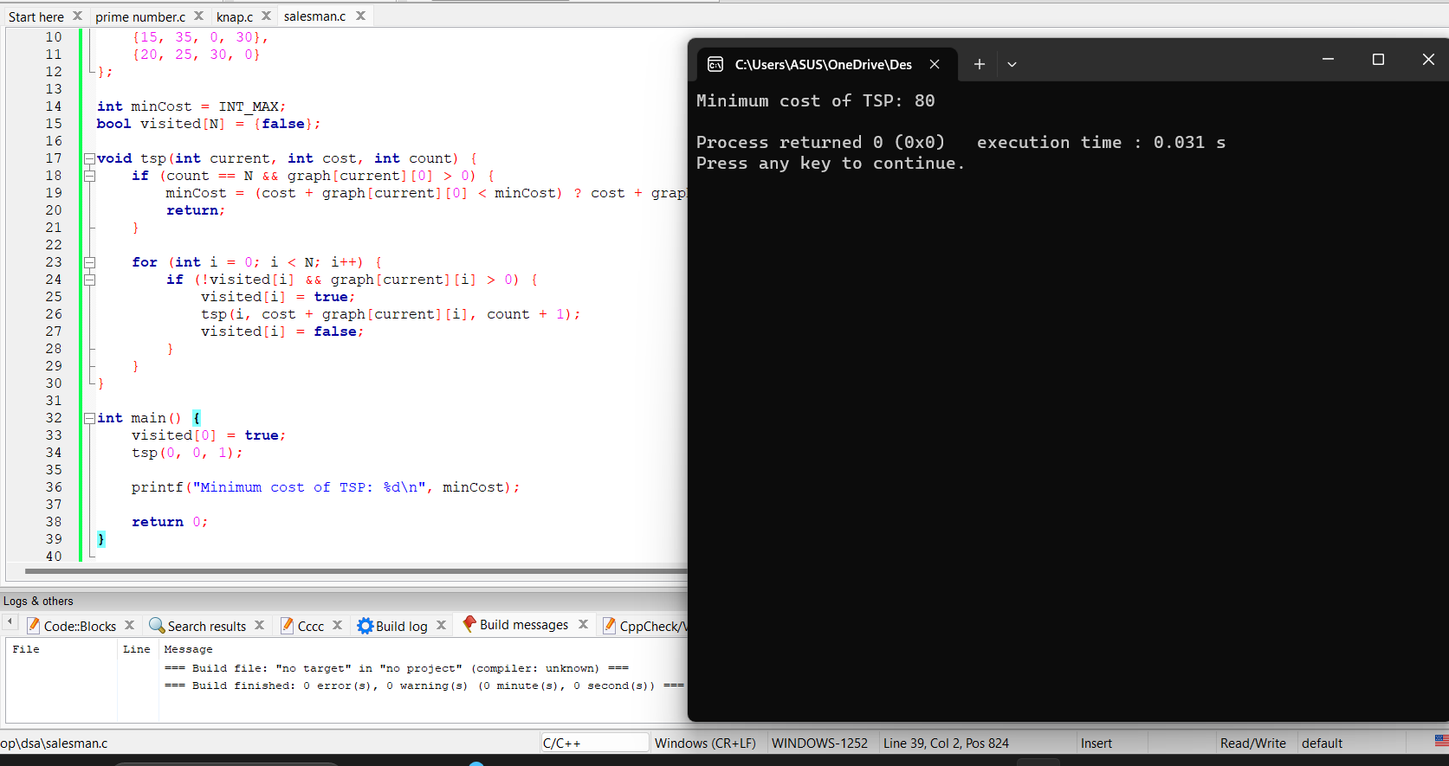

9. RANDOMIZED APPROACH

EXAMPLE 1 : Rolling a dice to get random numbers

#include <stdio.h>
#include <stdlib.h>
#include <time.h>
int rollDice() {
return rand() % 6 + 1;
}

int main() {
srand(time(NULL));

printf("Rolling the dice...\n");
int diceResult = rollDice();
printf("The dice rolled: %d\n", diceResult);

return 0;
}

OUTPUT :

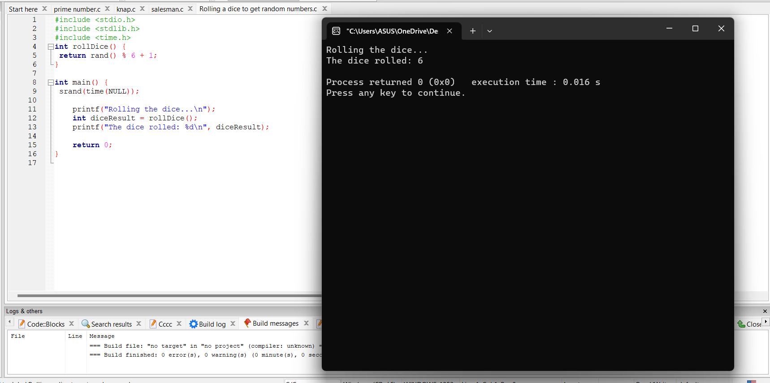

EXAMPLE 2 :
// Generating a random numbers with upper and lower limit using rand() function

#include <stdio.h>
#include <stdlib.h>
#include <time.h>
int main()
{
int lower, upper, count,i,num;
srand(time(0));
printf("enter the upper limit");
scanf("%d",&upper);
printf("enter the lower limit");
scanf("%d",&lower);
printf("enter the count limit");
scanf("%d",&count);
FILE *fptr;
fptr=fopen("bhuvan.txt","w");
if(fptr==NULL)
{
printf("error");
exit(1);
}
else
{
fprintf(fptr,"%d\n",count);
for (i = 0; i < count; i++)
{
int num = (rand() %
(upper - lower + 1)) + lower;
printf("%d ", num);

fprintf(fptr,"%d\n",num);
}}
fclose(fptr);
return 0;
}

OUTPUT :

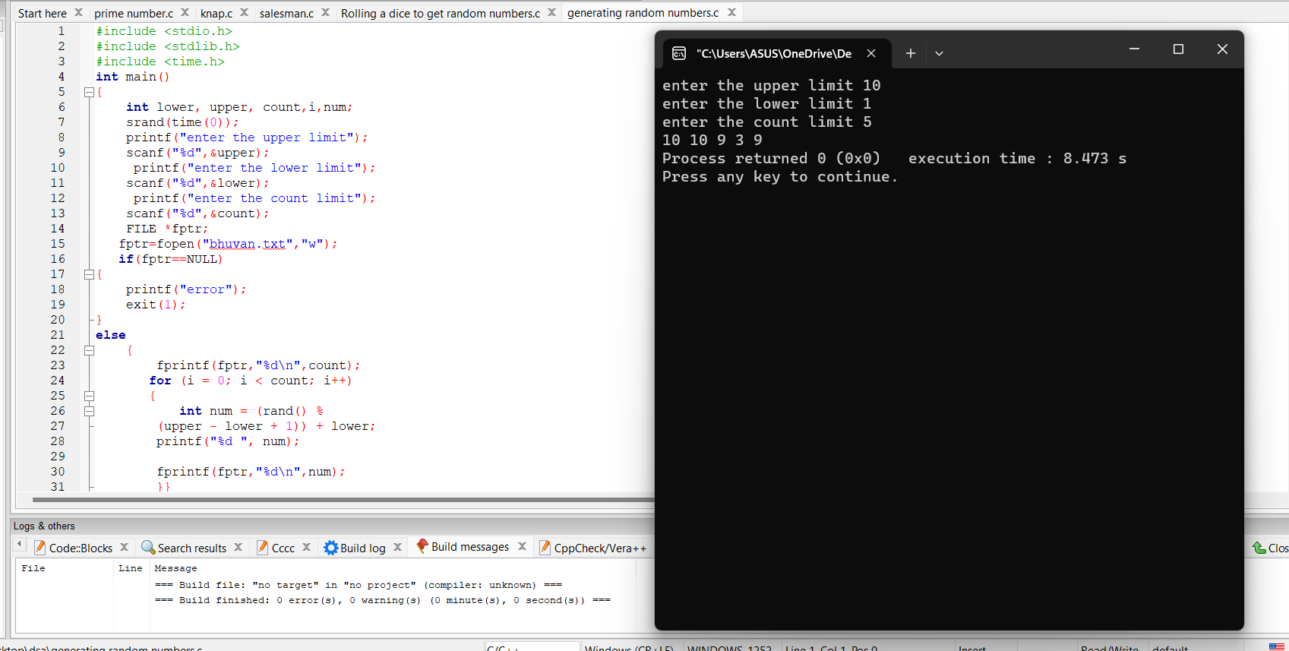

TIME COMPLEXITY CALCULATIONS:

- Iterative Approach

Example 1 :
File processing line by line
Opening a file-O(1) doesnot depend on the size of the file
Reading line by line and processing it –O(n)
Therefore ,
T(n) =O(n)

Example 2 :
Timer
Initialization – O(1) because it involves a simple assignment operation
While Loop – O(timer) The while loop iterates until the "timer" variable becomes less than 0. The number of iterations in the while loop is equal to the initial value of "timer" plus one, as the loop will execute even when "timer" is 0 before the decrement operation. Therefore, the time complexity of the while loop is O(timer).
Print Statement – O(1) it involves the printing the value of the timer which is constant
Sleep function will not have any time complexcity
Therefore the total time complexcity will be O(n).

- Recursive Algorithm

Example 1:
Exponential calculation
The time complexity of this program can be analyzed by looking at the recursive function power.
The power function calculates the result of raising base to the power of exponent. It uses recursion to repeatedly multiply base by itself for exponent number of times.
In the worst case scenario, where the exponent is a positive integer, the power function will be called recursively exponent number of times. This results in a linear relationship between the input size (exponent) and the number of function calls.
Therefore, the time complexity of the power function is O(exponent).
T(n) = O(exponent)

Example 2 :
Program to find the factorial of number 5
T(n) =1 for n=0
T(n) = 1+T(n-1) for n>0
So,
Time complexity = 0(n)

- Backtracking Algorithm

Example 1 :

C program to print all permutations with duplicates
T(n)=O(N * N!)
i.e. there are N! permutations and it requires O(N) time to print a permutation.

Example 2 :
N queens Problem
Let N be the number of variables (queens in this case) and M be the number of possible values (positions on the chessboard).
In the N-Queens problem, N is equal to M. The worst-case time complexity of backtracking is generally exponential,
T(n)= O(M^N).
In the N-Queens problem,
T(n)=O(N^N) ; since N = M.

- Divide And Conquer Algorithm

Example 1 :

Implementing the quick sort
Best Case: omega (N * log N)
Average Case: Theta (N * logN)
Worst Case: O(N^2)

Example 2 :

Implementing the merge sort
Merge Sort is a recursive algorithm and time complexity can be expressed as following recurrence relation.
T(n) = 2T(n/2) + θ(n)
T(n)= O(N log(N))

- Dynamic Programming

Example 1 :

Finding the Fibonacci number in a sequence
T(n)= O(n) ; because it iterates from 2 to n, performing a constant-time operation for each iteration.

Example 2 :

Solving the problem of finding the minimum number of coins needed to make change for a given amount
Solving the problem of finding the minimum number of coins needed to make change for a given amount
The time complexity of the dynamic programming approach to solve the minimum coin change problem is O(n * amount), where n is the number of coin denominations and amount is the given amount.
The algorithm iterates over each amount from 1 to the given amount and tries each coin denomination, resulting in an overall time complexity of O(n * amount).
T(n)=O(n*amount)

- Greedy Algorithm

Example 1 :

Function to find the minimum number of coins needed to make change
The time complexity of the Coin Change Problem using a greedy approach in C depends on the number of coins (numCoins) and the target amount (targetAmount).
Overall, the time complexity of the greedy approach for the Coin Change Problem is O(numCoins^2) or O(numCoins * log(numCoins)) depending on the sorting algorithm used.

Example 2 :

Greedy algorithm to solve the activity selection problem
The time complexity of this greedy algorithm is dominated by the sorting operation, which has a time complexity of O(numActivities * log(numActivities)).
using an efficient sorting algorithm like quicksort or mergesort. The subsequent iteration over the sorted list has a linear time complexity of O(numActivities).
T(n) = O(numactivities)

- Brute force Algorithm

Example 1 :
Brute force algorithm for finding pattern index
In a basic brute-force approach, the algorithm iterates through the text and checks for matches with the pattern at each position. The worst-case scenario occurs when the pattern matches at the last position of the text or does not match at all. In this case, the algorithm needs to compare each character of the pattern with the corresponding character in the text for every possible starting position.
Therefore, the time complexity of a brute-force pattern matching algorithm is approximately O((n - m + 1) * m), where n is the length of the text and m is the length of the pattern.
The term (n - m + 1) represents the number of possible starting positions in the text where the pattern could match, and m represents the number of character comparisons needed for each starting position.
T(n)= O((n - m + 1))

Example 2 :
Program to check the given number is a prime number or not a prime number
if a given number n is prime. In a brute-force approach, we iterate from 2 to n and check if n is divisible by any number in that range. If we find a divisor, then n is not prime. If we don't find any divisors, then n is prime.
In this approach, we iterate n times, checking each number in the range. Therefore, the time complexity of a brute-force prime number check algorithm is approximately O(n).
T(n) =O(n)

- Branch and bound

Example 1 :

Knapsack Problem
Time Complexity = Exponential, O(2^n)

Example 2 :

Salesman problem
Time Complexity= Exponential, O(N!)

- Randomized Approach

Example 1 :
Rolling a dice to get random numbers

Overall, the time complexity of simulating rolling a dice using randomization in C can be considered to be constant, assuming that the random number generation functions (rand() and srand()) have constant time complexities in the specific environment in which the code is executed.
T(n)=O(1)

Example 2 :

Generating a random numbers with upper and lower limits using rand() function

The time complexity of generating n random numbers would be O(n). This is because you would need to call the random number generation function n times to generate all the numbers.
T(n)=O(n)

